Notes on Crampton QA/QC for GLEON metab/catchment group

Jake Zwart; 2016-02-16

**QA/QC overview**

**METADATA**

*Crampton DO sensor depth* = 0.5 m.

Ave Elevation = 511 m

*windHeight* <- 2 m #height above lake at which wind speed is meaured

*timeStep* <- 10 #number of minutes between DO measurements

*lat =*  46.21046 #latitude of Crampton

**DO file**

No NA’s / missing data;

Range = 7.26- 10.47 mg L-1

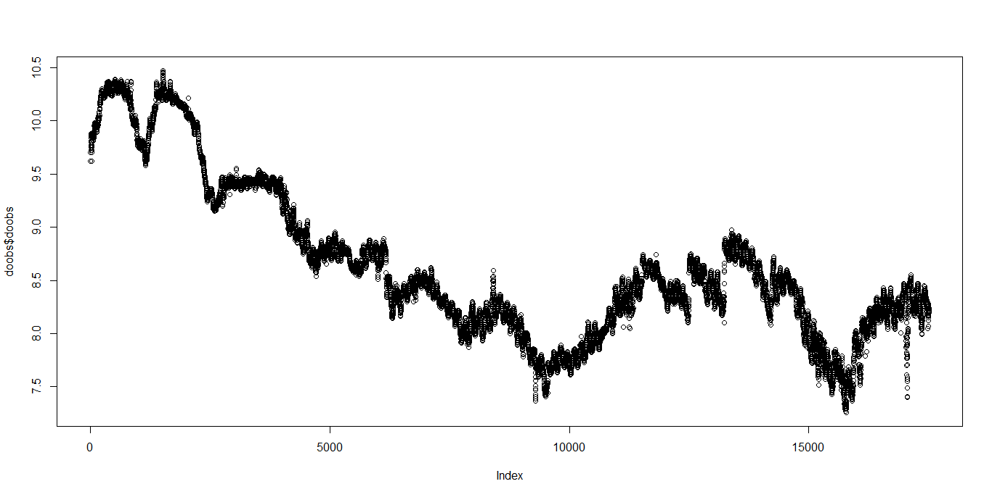

**Wind speed file**

No NA’s / missing data; no obvious anomalies

Range = 0 – 6.49 m s-1

**PAR file**

No NA’s / missing data; no obvious anomalies

Range = 1.2 – 2553.7 umol m-2 s-1 (1.2 is the minimum measurement from Onset light sensors – occurs at night)

**Thermistor data file**

Some missing data (filled in as NA’s) at 7 m from May –July

No obvious anomalies

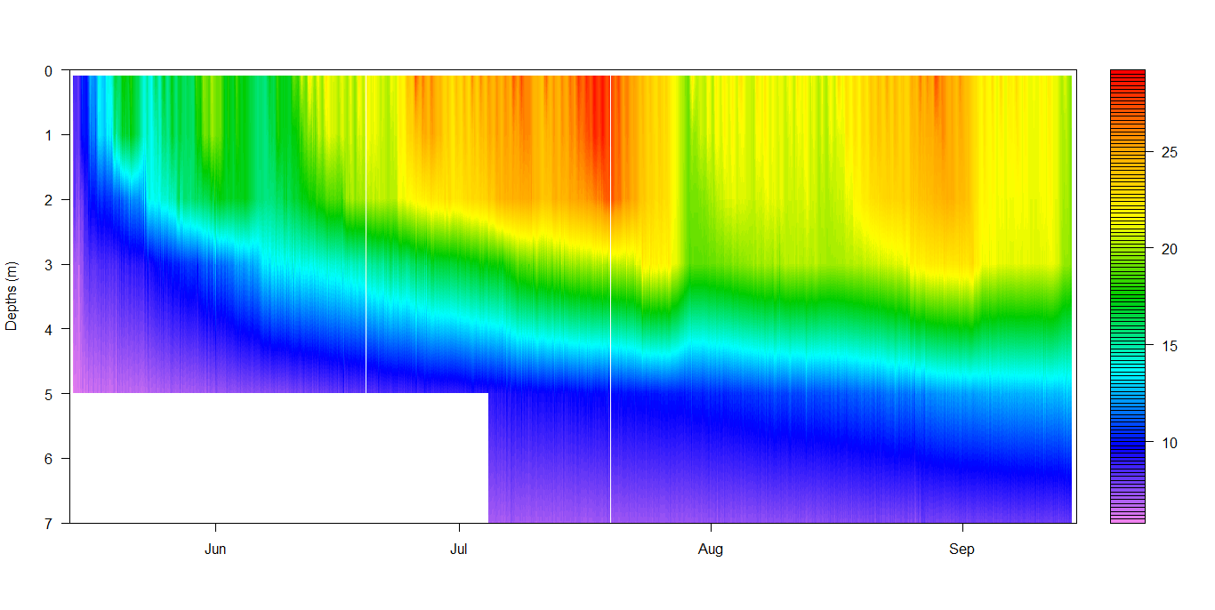

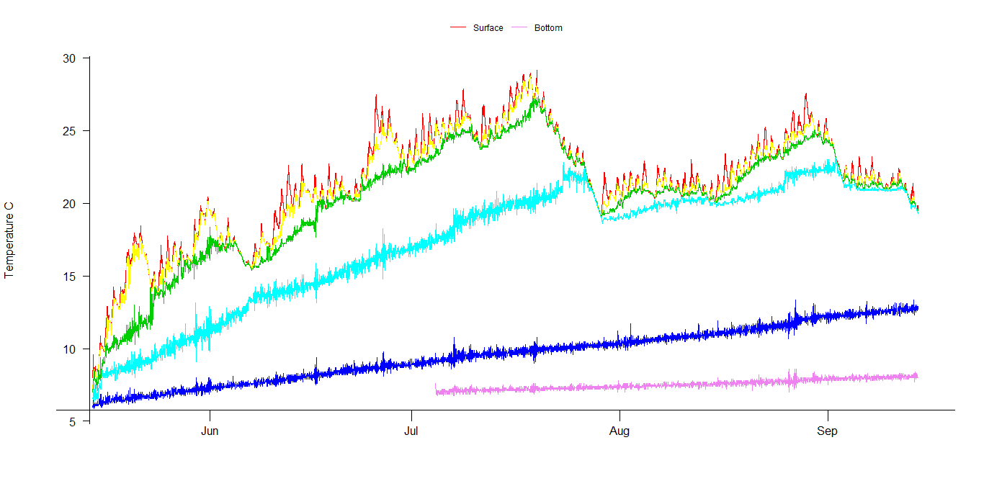

Heat map of thermistor profile